For each of the 3 figures below, indicate which “Graphical Excellence” principles are violated. Provide an alternative display of the information (hand drawn), making sure you follow the ‘Graphical Excellence’ principles.
- Figure 1 from Wiesenborn et al. The effect of calorie restriction on insulin signaling in skeletal muscle and adipose tissue of Ames dwarf mice. Aging 2014; 6(10):900-912.
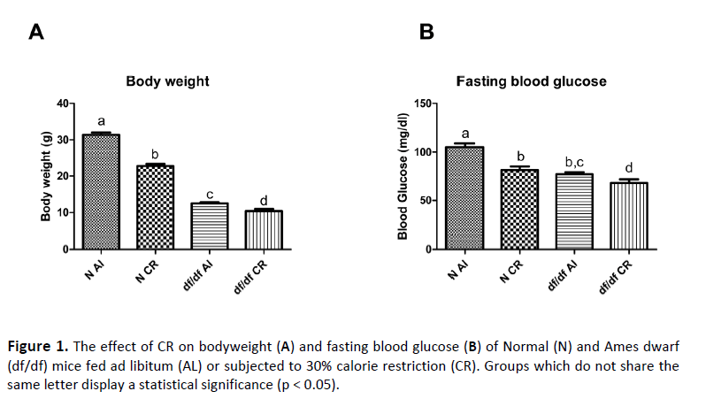

- Figure 3 from Schisterman et al. Failure to Consider the Menstrual Cycle Phase May Cause Misinterpretation of Clinical and Research Findings of Cardiometabolic Biomarkers in Premenopausal Women. Epidemiol Rev 2014;36:71–82
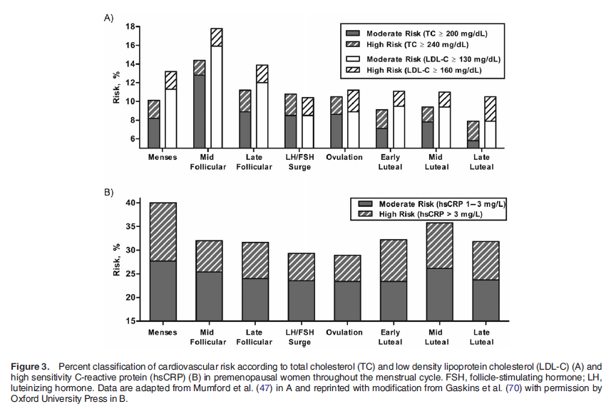

- Figure from Diagraphics II, Nihon Kurieitāzu Kyōkai, JCA Press, 1994.
