Additional Online Courses
After successfully completing joint field training, participants can take additional online courses. These are required for standardization.
COMMUNICATION
Active Listening Skills | EHS02
EPIDEMIOLOGY
Foodborne Illness Investigations 1: Collecting Surveillance Data | FI01
Foodborne Illness Investigations 2: Beginning the Investigation | FI02
Foodborne Illness Investigations 3: Expanding the Investigation | FI03
Foodborne Illness Investigations 4: Conducting a Food Hazard Review | FI04
Foodborne Illness Investigations 5: Epidemiological Statistics | FI05
Foodborne Illness Investigations 6: Final Report | FI06
MICROBIOLOGY
Food Microbiological Control 7C: Control by Retorting | MIC10
Food Microbiological Control 8: Technology-Based Food Processes | MIC11
Food Microbiological Control 9: Natural Toxins | MIC12
ALLERGEN Management
Food Allergens | FD252
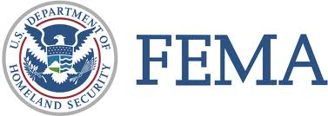
EMERGENCY MANAGEMENT
Introduction to Incident Command System (ICS) | IS-100a or IS-100 for FDA
ICS for Single Resources and Initial Action Incidents | IS-200a
National Incident Management Systems (NIMS) Introduction | IS-700a

